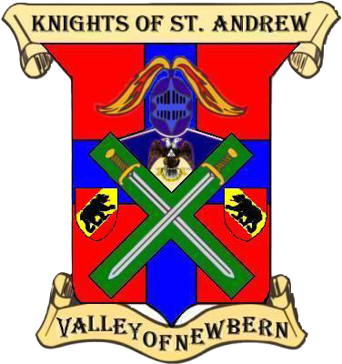

|  |  |
| --- | --- |
| **Valley of New Bern, Knights of Saint Andrew 2024 Officers** | |
| Knight Commander | Bill Sanford Jr. |
| Knight Warden | Mark Brewington |
| Knight Captain | Tim J. Harris |
| Knight Exchequer | Edward A. Shannon |
| Knight of the Seal | Dustin M. Wood |
| Knight Quartermaster | Sam T. Gilliland |
| Knight Guard | Esteban Gonzalez |
| Knight Sacristan | Tom E. Simmons |
| Knight Sentinel | Fred H. Witty III |

|  |  |
| --- | --- |
| **Valley of New Bern, Knights of Saint Andrew 2024 Charter Members** | |
| Sir Knight* | M. Bill Sanford Jr. |
| Sir Knight | S. Mark Brewington |
| Sir Knight | Dustin M. Wood |
| Sir Knight | Tim J. Harris |
| Sir Knight | Edward A. Shannon |
| Sir Knight | Sam T. Gilliland |
| Sir Knight | Billy Ray Askew |
| Sir Knight | H. Wayne Cox |
| Sir Knight | Esteban Gonzalez |
| Sir Knight | Frederick H. Whitty III |
| Sir Knight* | Tom E. Simmons |
| Sir Knight* | B. Keith Phelps |
| *denotes Legacy from original Chapter |  |